* Non-zero set points controllers

1. Problem

1.1 Introduction:

Up to now we consider the outputs are convergent to zero for any initial states values. We may call this controller as a regulator controller. Sometimes we need the outputs may be anon-zero points, or prescribed values. We may call this problem as a non-zero set point problem.

For example, the output may be the reference point, which is a input.

The output ~ the reference input.

In the UG course, in the introduction to control, you may remember the final value theorem. Let’s remind of what this is.

1.2 The final value theorem

Given the transfer function $H(s)$, which is **asymptotically stable**. Let the input is a A valued step function, i.e., its transfer function is

$$R\left(s\right)=\frac{P}{s}$$

Hence the output is

$$Y\left(s\right)=H\left(s\right)R(s)$$

According to the final value theorem,

$$\lim_{t→∞}{y\left(t\right)= \lim_{s→0}{sY(s)}= \lim_{s→0}{sH\left(s\right) \left(\frac{P}{s}\right)= \lim_{s→0}{H\left(s\right)=PH(0)} }}$$

Hence, the output value is converge to $PH(0)$

1.3 The prefilter(pre-gain) for non-zero set-point controller

- Consider in frequency domain, following a block diagram

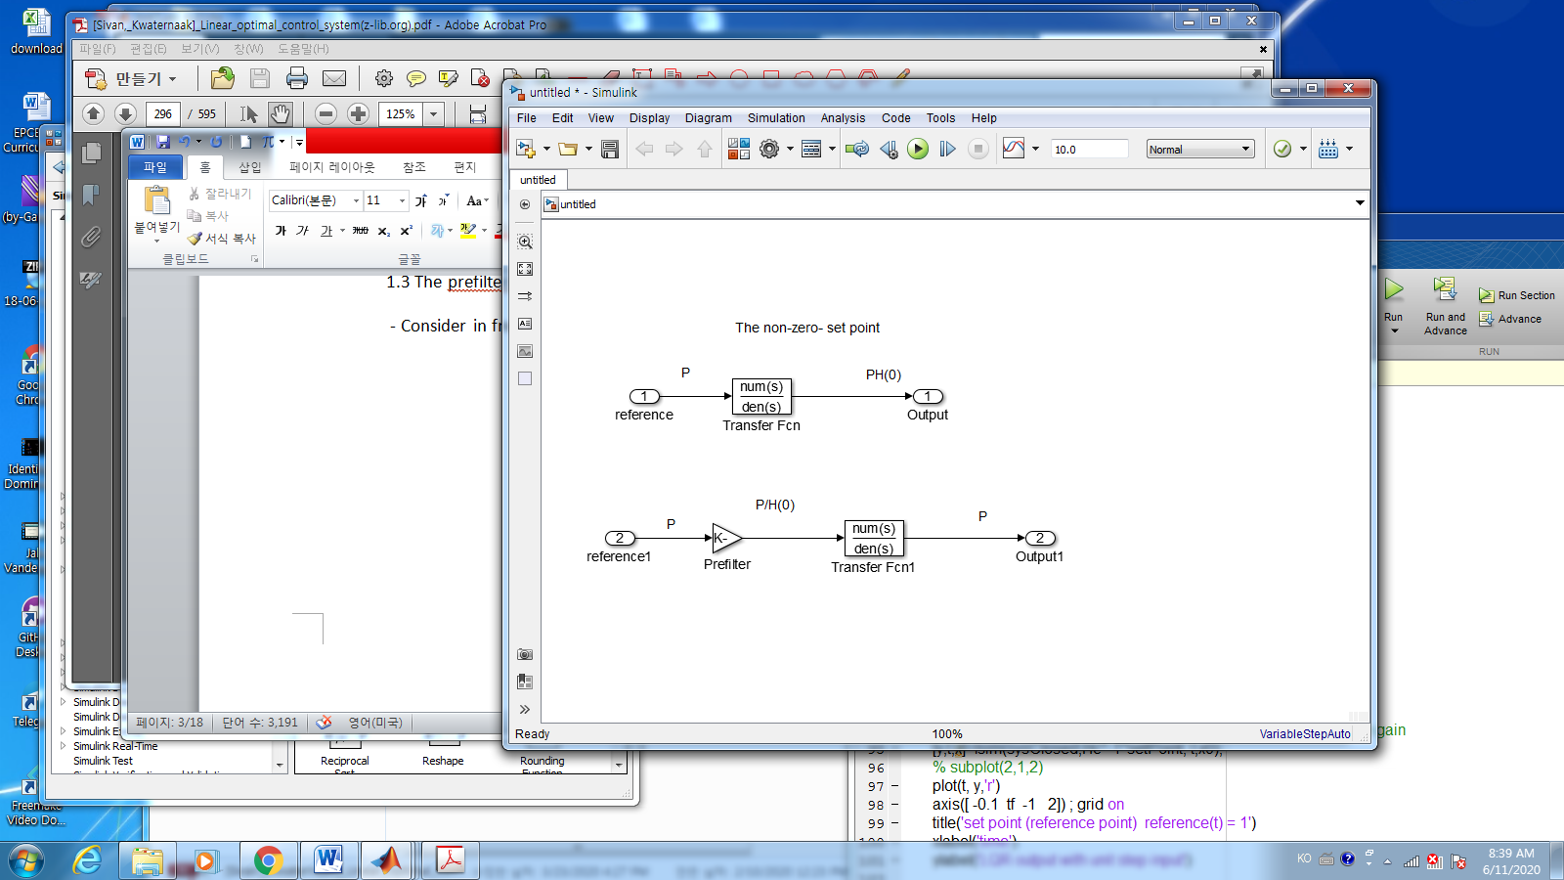

In order for the output is the same to the input reference set point, we need a prefilter,.i.e., pre-gain adjustments. Above the block diagram, if the gain of the prefilter is $1/H(0)$, the output will be the same to the reference value in the time limit(Be sure, the plant should be asymptotically stable)

* In the state space model

$$\dot{x}=Ax+Bu, y=Cx$$

In the regulator problem, you may find a controller such that the closed loop is asymptotically stable, for example $u= -Kx,$ where $K$ is the optimal regulator control gain. With this regulator controller, the output will be convergent to zeros, hence in order for the output to be a set point,(reference input), we need additional controller as

$$\dot{x}=Ax+B(-Kx+H{\left(0\right)}^{-1}P), y=Cx$$

Then $y=P$ in the steady state.

* Comparison between LQR and PI control - Example 3.4 / Example 3.8

In this context, I will compare LQR with P and PI controllers, with regards to the rising time of the output. The rising time is one of the important characteristics for the controller. The rising time mainly depends on the poles of the closed loop system, especially the poles whose the real part is closed to the zeros. Let’s investigate the poles of different controlles.

1. The state equation

DC motor:

$$\dot{x}=\left[\begin{matrix}0 & 1 \\ -1 & -α\end{matrix}\right]x+\left[\begin{matrix}0 \\ κ\end{matrix}\right]u x={\left[θ \dot{θ}\right]}^{T} \\ y=[1 0]x$$

Where

$$α=4.6 s^{-1} \\ κ=0.787 rad/Vs^{2}$$

1. The open loop system characteristics
   * the transfer function

The open loop transfer function is

$$open loop TF= \frac{0.787}{s^{2}+4.6s}$$

so that the poles are

$$poles =[0 , -4.6]$$

It is marginally stable.

* + Initial state response

With the initial points [-1,0], the states remain constant. See the below figure

* + The step response

Let’s see the output with a step input;



Since there is a zero at $s=0$, with the step input, the output will be diverges.

1. LQR controller - Optimal controller

3.1 The optimal controller

With the cost function as

$$J =\int_{0}^{∞}{{(x}^{T}Qx +u^{T}Ru}) dt=\int_{0}^{∞}{{(y}^{2}+ρu^{2}}) dt$$

The weighting matrixes are $Q=C^{T}C, R=ρ=0.00002.$

From the theorem

$$u= -R^{-1}B^{T}Px$$

where P comes from the Riccati equation

$$A^{T}P+PA+Q-PBR^{-1}B^{T}P=0$$

then the matlab command is used as

>> [K,P,E] = lqr(sysO,Q,R)

Hence the optimal controller is

$$u= -B^{T}R^{-1}P x= -Kx=-\left[223.6068 18.6992\right]x$$

This is a full state $(x_{1}, x_{2})$ feedback. Without the observer, you need the full information

of the states

* 1. The closed loop characteristics

3.2.1 The closed loop transfer function

$$LQR closed loop TF=\frac{0.787}{s^{2}+19.3162s+175.9785}$$

So that the poles of it are

$$poles =[-9.65±9.09i]$$

You may see the real parts 0f closed loop poles are far away from zero. It should be remembered for the comparison with Proportional and Integral (PI) controller.

* + 1. Initial state response

The control input $u= -Kx$, the closed loop is asymptotically stable, for any initial points the states converges to zeros.



* + 1. The non-zero set points controller - step response

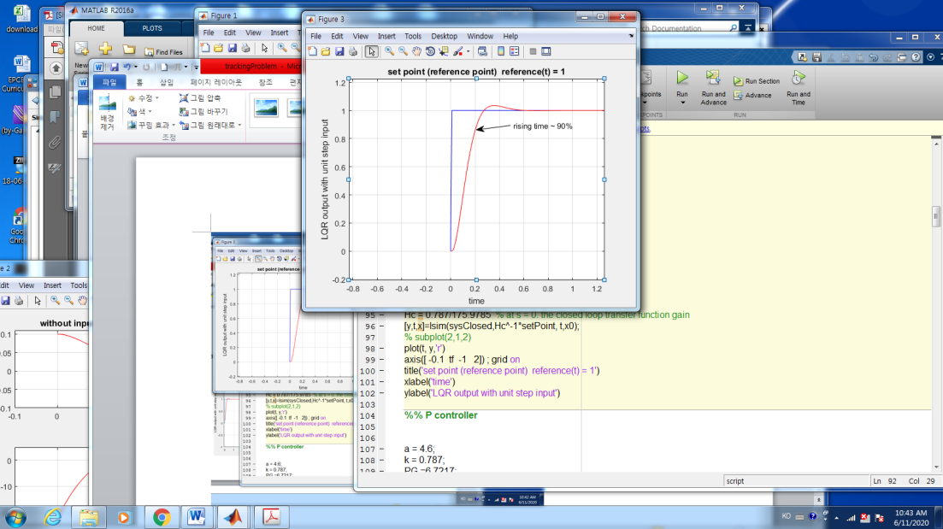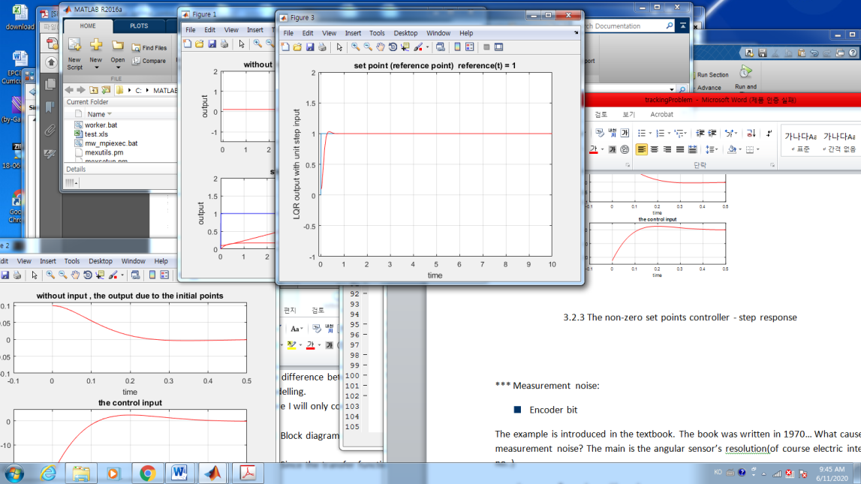

You may see the rising time is **less than 0.2 sec,** the output is convergent to the set point.

1. Proportional and integral control

Proportional, Integral and derivative controller is popular in manufacturing society. Even if it is called as a classic control, it has main merits over a modern control (LQG,..). The main advantage is simple and has a lot of materials. Laplace, Bode, Root locus,…Huge material.

The difference between classis and modern control is , in general, the state – space modelling.

Here I will only concentrate on PI controller.

* 1. P controller

4.1.1 Closed loop with “P” controller

Since the transfer function of (1) is

$$\frac{κ}{s\left(s+α\right)}$$

One of the state space realizations is

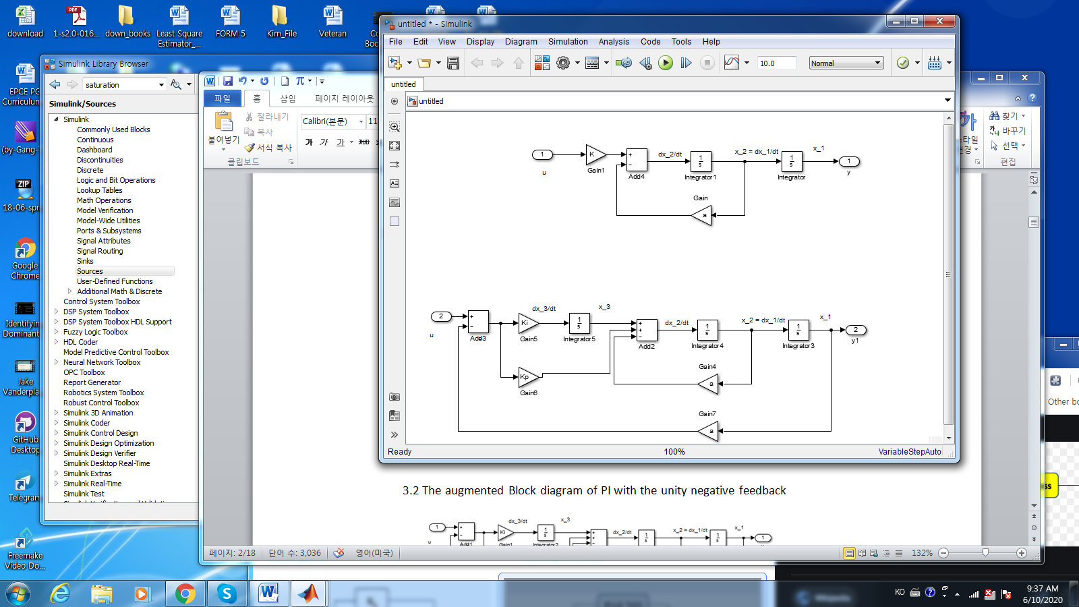

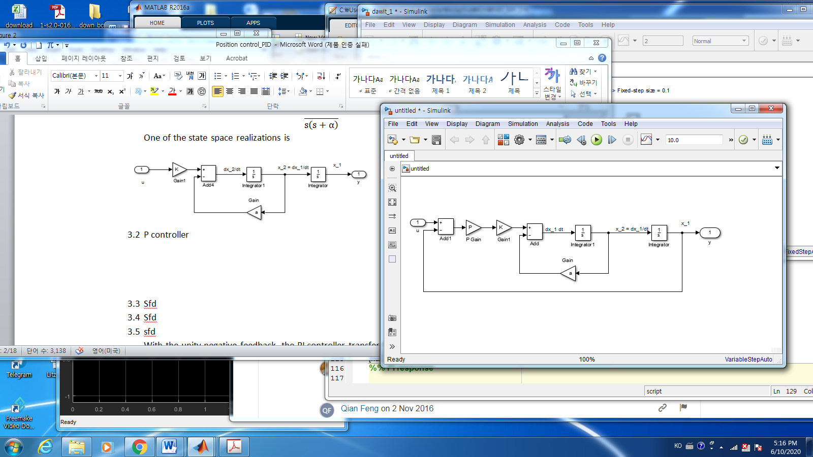Then the closed loop with P controller

O4.1.2 The State- space model

Hence one of the equivalent state space models is

$$\dot{x}=\left[\begin{matrix}{\dot{x}}_{1} \\ {\dot{x}}_{2}\end{matrix}\right]=\left[\begin{matrix}0 & 1 \\ -PK & -α\end{matrix}\right]x+\left[\begin{matrix}0 \\ PK\end{matrix}\right]u x={\left[θ \dot{θ}\right]}^{T} (2) \\ y=[1 0]x$$

4.1.3 The poles of the closed loop Transfer function

For $α=4.6 s^{-1}, κ=K=0.787 rad/Vs^{2}$, the characteristic equation is

$$s^{2}+4.6s+0.787P=0$$

Let’s assume the poles as (a,b) . Then the characteristic equation is

$$s^{2}+\left(a+b\right)s+as=0$$

Hence for any P, The sum of closed loop poles is 4.6 , so that the real part of closed loop poles are no less than -4.6.

To get the minimum rising time, we may assume the minimum of the absolute values of the poles is 2.3, which implies the poles are

$$(-2.3, -2.3)$$

In this case $P=6.7217$.

4.1.4 The step response

Since the $H_{c}\left(0\right)=1,$ and with initial point as $(0,0)$, the step response is

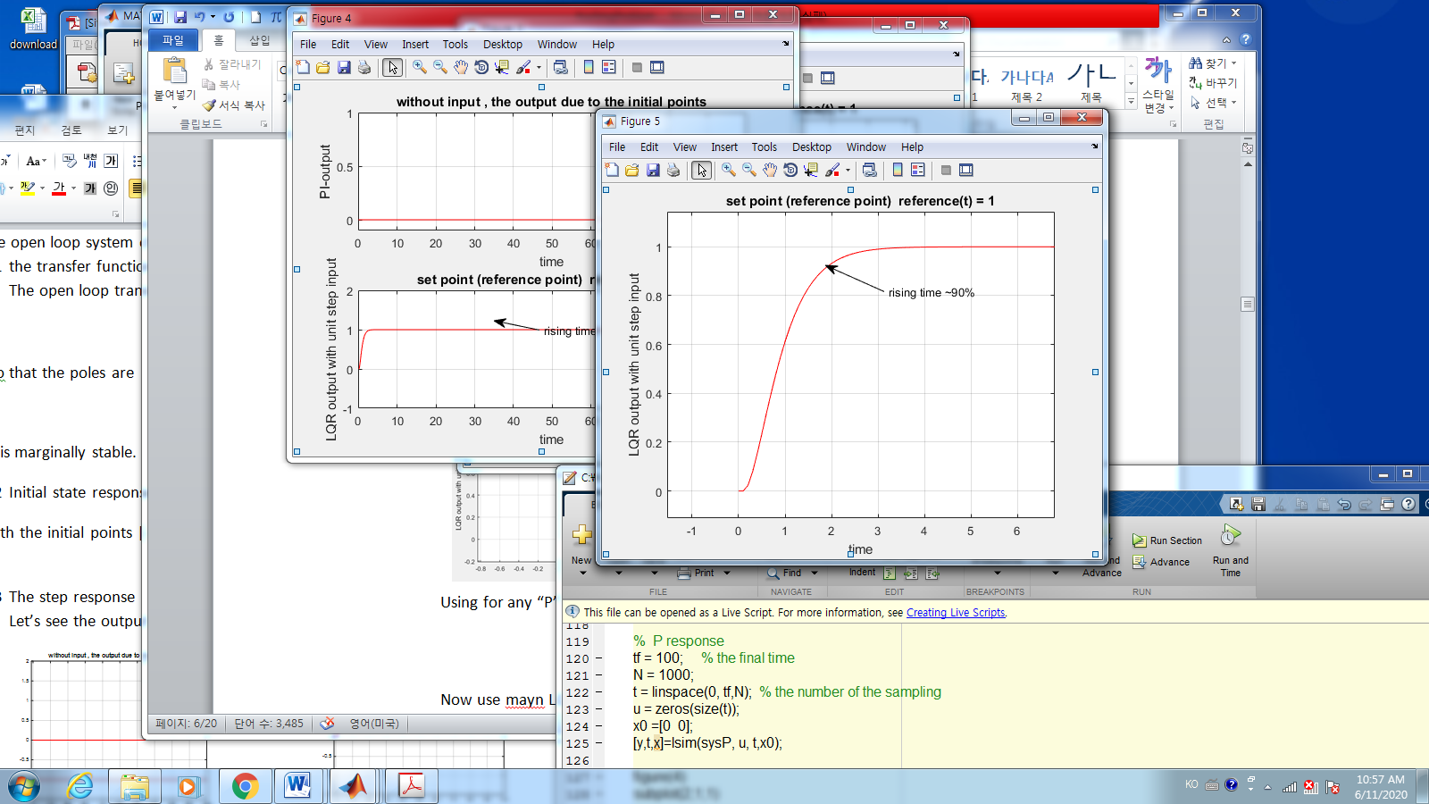

Using for any “P” controller **you may not get the smallest rising time 1.7 seconds.**

* 1. PI controller

4.2.1 Closed loop with “PI” controller

With the unity negative feedback, the PI controller transfer function is

$$\left(PG\right)+\frac{IG}{s};$$

$IG:$ the integral gain

$PG:$ The Proportional gain

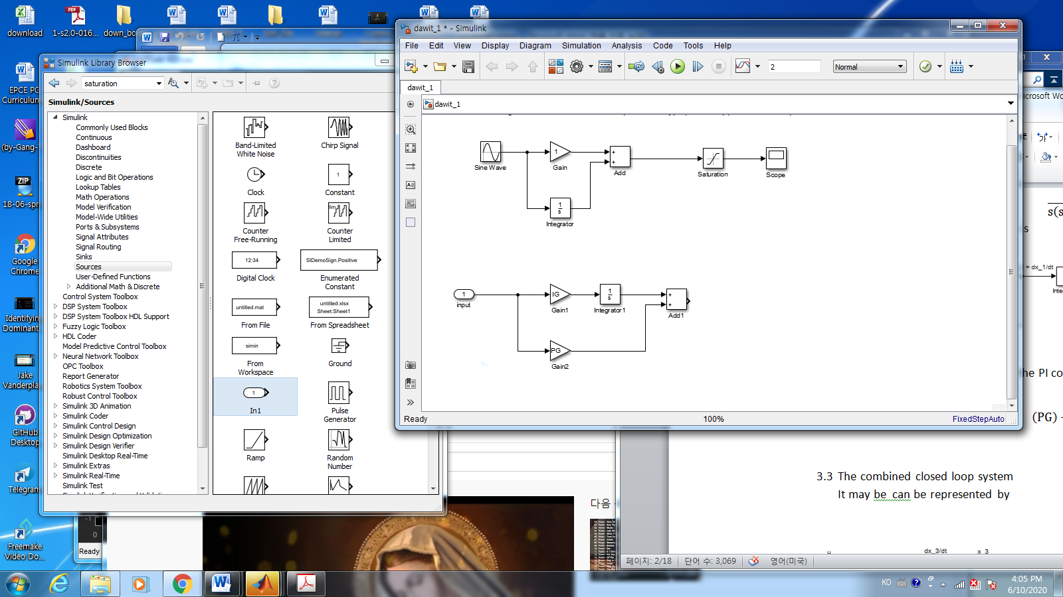

4.2.2 The state space model

The state space model of the combined closed loop system may be represented by

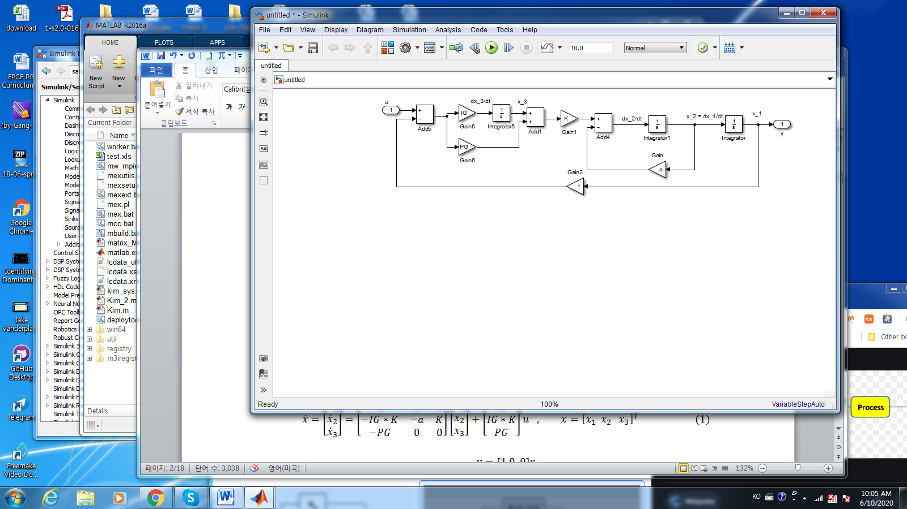

So Now the PI state space model is

$$\dot{x}=\left[\begin{matrix}\dot{x_{1}} \\ {\dot{x}}_{2} \\ {\dot{x}}_{3}\end{matrix}\right]=\left[\begin{matrix}0 & 1 & 0 \\ -PG*K & -a & K \\ -IG & 0 & 0\end{matrix}\right]\left[\begin{matrix}x_{1} \\ x_{2} \\ x_{3}\end{matrix}\right]+\left[\begin{matrix}0 \\ PG*K \\ IG\end{matrix}\right]u , x={\left[x_{1} x_{2} x_{3}\right]}^{T} (1)$$

$$y=[1 0 0]x$$

4.2.3. The poles of the closed loop Transfer function

Let’s check the poles of the PI system. For $α=4.6 s^{-1}, κ=0.787 rad/Vs^{2}$.

the characteristic equation is

s^3 + (23*s^2)/5 + (787*PG*s)/1000 + (787*IG)/1000

Assume the 3 poles are $(a,b,c)$ then the polynomials with 3 poles are

$$s^{3}+\left(a+b+c\right)s^{2}+\left(ab+ac+bc\right)s+abc=0$$

Since the coefficient of $s^2$ is fixed as 23/5, for any gains of PG or IG , the closed loop system poles $\left(a,b,c\right)$ should be

$$a+b+c=\frac{23}{5}$$

In order to have the smallest rising time, we may assume the poles are all the same place as

$$\frac{\left(\frac{23}{5}\right)}{3} \sim 1.533$$

To have these poles

$$PG\sim 8.96, IG\sim 4.58$$

In these values the closed loop poles are

$$\left(a,b,c\right)\sim (-1.68, -1.47±0.13i)$$

4.2.4 The step response

Since the $H_{c}\left(0\right)=1,$ and with initial point as $(0,0)$, the step response is in the following figure.

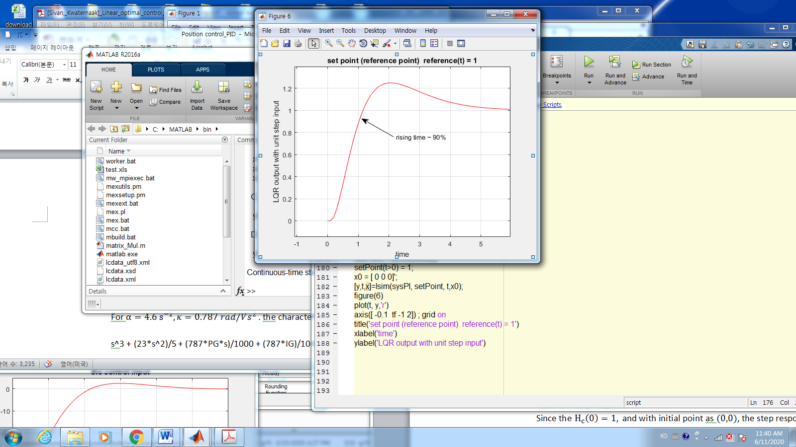

Now the minimum rising time with for PI controller is 1.2 seconds.

1. The comparison w.r.t rising time

So far the LQR controller gives the minimum rising time compared to “P” or “PI” controllers.

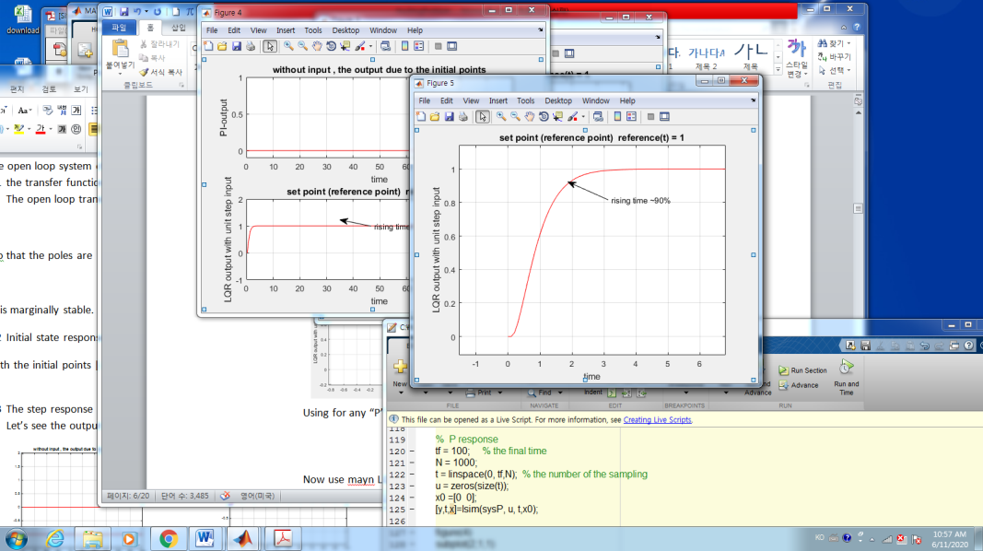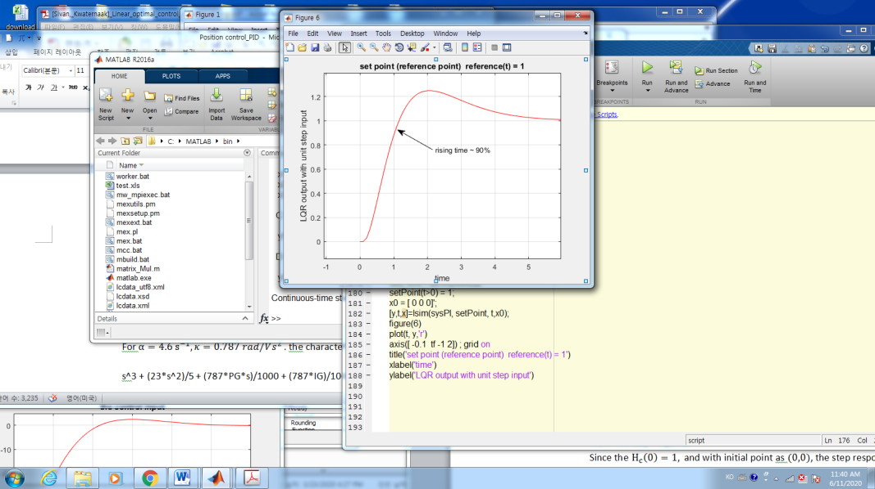

The figures are the step responses using LQR, “P” and “PI” controller

The LQR performance is the best w.r.t the rising time. The rising time is important in the case of tracking problem. The shortest is the best. How about the other performance index such as

* Disturbance / noise rejection
* The plant model uncertainty

Still LQR is in general the best. Why is this happened? Because LQR controller is a full state feedback whereas P and PI are output feedback.

Now If only the output is available, how about LQR? 🡪 the state observer / estimator.